Tab 1

Modeling and Payload Analysis of an Anthropomorphic Robotic Hand
I.Rohan Aaron¹, Dr. P.V.S Subhashini²,Y. Varun³
¹ Department of Mechanical Engineering, Vasavi College of Engineering, Hyderabad, India, indupallyr@gmail.com, +91 7093658471
²Department of Mechanical Engineering, Vasavi College of Engineering, Hyderabad, India, pvs.subhashini@staff.vce.ac.in +91 80195 41938
³Department of Mechanical Engineering, Vasavi College of Engineering, Hyderabad, India, varunyemmanur03@gmail.com, +91 88972 13753

Modeling and Payload Analysis of an Anthropomorphic Robotic Hand

Abstract
This paper presents the Modelling and analysis of an Anthropomorphic Robotic hand. The objective is to model an agile and flexible, yet tough and rigid arm for industrial applications. And to conduct static structural analysis using the concepts of finite element analysis on each and every part of the model, applying maximum empirical boundary conditions, using CAE softwares, and Choosing appropriate materials, based on the results showcased through the static structural analysis done on the model.

1. Introduction
The purpose of this kind of model is to achieve a comfortable level of flexibility and agility while maintaining strength and rigidity. To maintain high standards in regards to strength and rigidity, a material survey has been done, to choose materials that show toughness and strength amidst the maximum load conditions. Having shortlisted a few materials for manufacturing of the said hand, Static structural force analysis was done using the concepts of Finite element analysis. The analysis was done such that the final chosen material stood the test of high loads. resulting from which two parameters were observed which were, FOS (Factor of safety), and Maximum deformation. Keeping these two parameters in mind, the best material for the manufacturing of the robotic hand was chosen for industrial application.

2. Literature review
Zahnupriya Kalita’s et al. [1] paper portrayed a methodology, showing the force application during the static structural analysis on the robotic hand model, it provided insight into the force distribution and direction of force to be applied. This paper provided instrumental guidelines by showing how to apply forces effectively in the FEA analysis of the robotic hand.

Ahmad Ghanbari et al. [2], focused primarily upon the flexibility of robotic arms. This paper aided in the determination of the work volume of the robotic hand, it also gave good insights into optimizing the robot’s hand, to attain a comfortable level of flexibility.
Joel A. Cort's, et al. [3] paper on determining the maximum load conditions played a pivotal role in the payload analysis of the robotic hand. This paper led the way to estimating the maximum forces to be applied, hence leading to a proper material selection. A maximum load condition of 268 N for all the fingers collectively and 59.5 N for each individual finger was stated in the paper which aided in the static structural analysis.
A paper authored by Li Tian, et al. [4] shed light on the moment of human fingers. By elucidating, the biomechanics of finger movement, this paper gave valuable insights regarding the functionality and versatility of robotic hands. It clearly explained the human finger dexterity which helped in the development of more agile manipulation Capabilities.

In Maxime Chalon's et al. [5] paper the positioning of the thumb in the hand was addressed in a very innovative manner, which was an inspiration by the thumb modeled in the robotic hand. This paper showcased the thumb's optimal positioning and movement along with showing more effective gripping mechanisms.

Ever Grisol de Melo’s et al. [6] Paper played an instrumental role in deciding a suitable material for the robotic hand, in the light of the set maximum boundary conditions. The paper emphasized the significance of the material CFRP(carbon fiber refined plastic) and portrayed its relevance in the Robotics industry while also showing its major advantages.
Agusril Syamsir’s et al. [7] showed that carbon fiber-reinforced polymer (CFRP) bridges are lighter than aluminum alloy bridges. The study found that a 150 mm deflection aluminum alloy bridge weighs 42.8 tons, while a CFRP bridge weighs 16.4 tons. This helped in deciding the fabricating material of the robotic hand.
Gurudu Rishank Reddy’s et al. [8] Thesis from Blekinge Institute of Technology introduced the concept of Ashby charts without which the material selection would not have been as accurate. The Ashby charts show different parameters of different materials as a scatterplot from which appropriate material materials for the set boundary conditions were chosen.

3. Modelling
All parts of this model are inspired by the anatomy of the human hand, and the dimensions are obtained by measuring a real hand to mimic the shape and size of a real-life human hand. A CAD model . Each individual part was modeled in a separate part environment, and all the parts were brought to the assembly environment and suitable mates were established among respective surfaces to obtain the final assembly of the robotic hand.

The first part that was modeled was the finger base as depicted in Fig.1 The basic model is that of an elliptical frustum with extrusion and cuts to mate with the palm of the hand and the tip of the finger. Sufficient clearance was provided for this part, even when the finger was bent completely

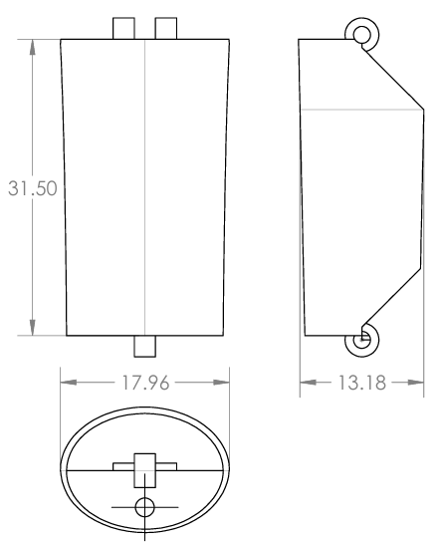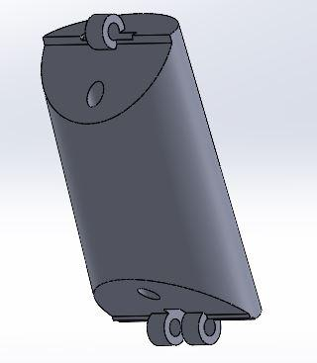
- Dimensions and part picture of the finger base

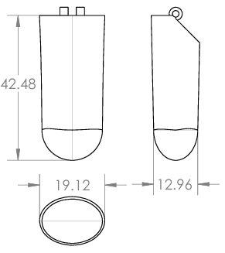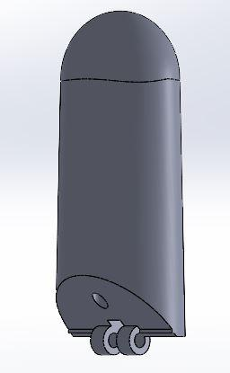
- Dimensions and part picture of the fingertip
After the finger base, the fingertip was modeled as shown in Fig. 2, with the same dimensions except the tip, the tip was made to resemble a human finger. i.e. a hemi ellipsoid. The bottom part had grooves to mate with the finger base. After the finger was completely modeled, next came the upper palm as shown in Fig.4. This part connected the index, middle, ring, and little fingers to the rest of the hand. This part mates perfectly with the bottom part. This part is modeled separately rather than modeling, only a single palm to provide a bend in the middle of the hand as depicted in Fig.3.
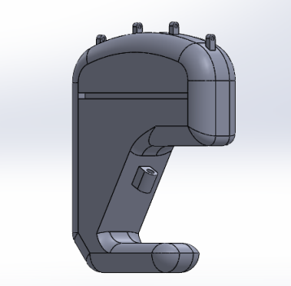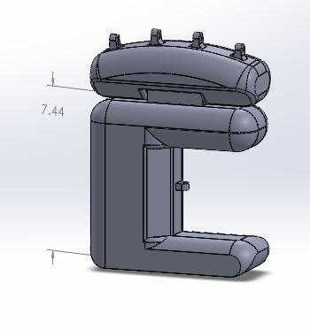
- Single and double palm comparison
which would aid to better grip an object, as with the upper palm and the lower palm, there will be more surface of contact with the object in the hand when compared to a single palm as shown in Fig.5.

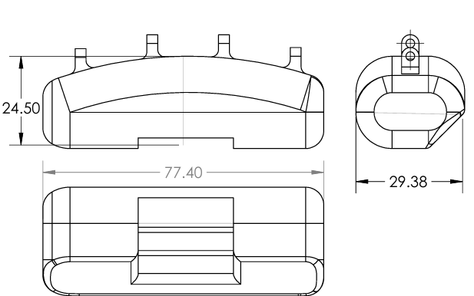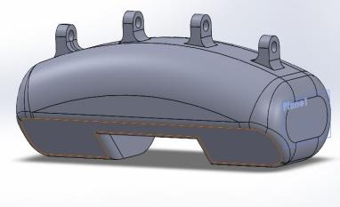

- Dimensions and part picture of the Upper palm
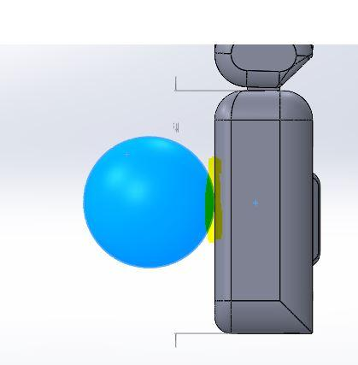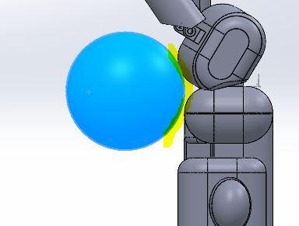
- Single palm and double palm contact surface
After the upper palm, the next part that was modeled was the lower palm as shown in Fig.6 , which acts as the backbone of the entire model. It bears most of the weight, has the largest surface area, and connects the hand to the rest of the arm. It also connects the upper palm anthem arrangement, giving us a full-hand picture.

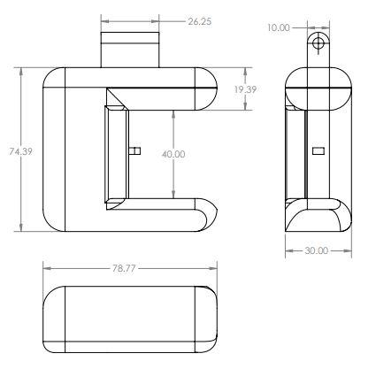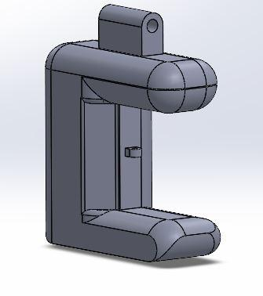
- Dimensions and part picture of the Lower palm

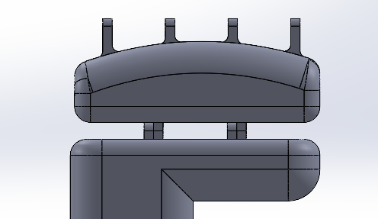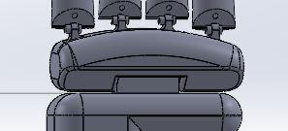
- Hinge model comparison

While assembling the individual parts and providing mates, two different hinge models were considered as shown in Fig. 7, from which the second hinge model was chosen for two reasons. The first one being, the lesser gap seen between the palm and the fingers which gives a seamless look. And the second being more area of contact resulting in higher friction and higher strength to withstand higher loads and low slipping chances.

Following the model of the four fingers, and both the palms was the modeling of the thumb arrangement, which is basically the thumb base and thumb tip as depicted in Fig.8. The base of the thumb is hinged to the palm perpendicular to the rest of the fingers to enable the tip of the thumb with more flexibility. The thumb base has its own groove in the lower palm model as seen in Fig.9. This is to enable the thumb with a more gripping surface area.

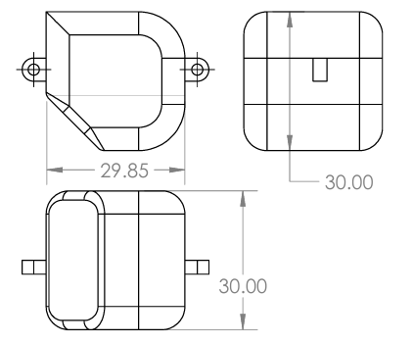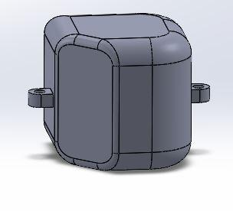
- Dimensions and part picture of the Thumb base
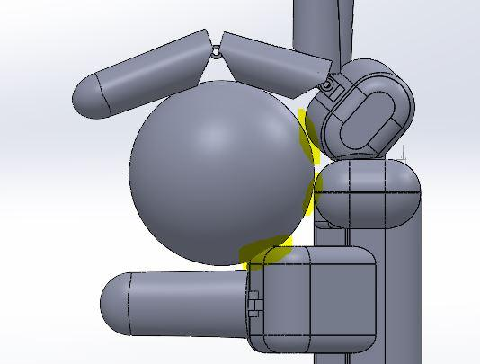
- Addition contact of thumb with object
As mentioned earlier with two palms, a greater contact area is established, with the thumb base able to move perpendicularly to the palm. It gives an additional surface to grip the object. Mounted on the base of the thumb is the tip of the thumb, which is similar to the tip of the other fingers i.e. a hemi ellipsoid mounted on an elliptical frustum. The tip is hinged to the thumb base to complete the thumb arrangement. Having finished modeling all the individual parts in their respective part environments, the assembly of all these parts was done in the assembly environment As shown in Fig.10. By giving the hinges mates with other respective parts.

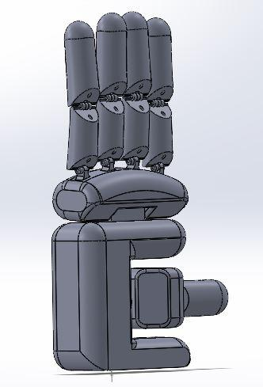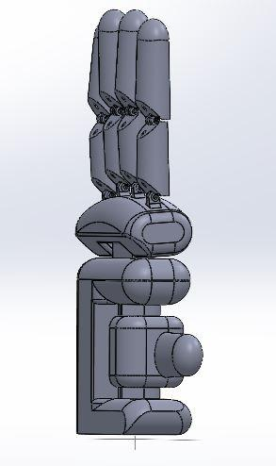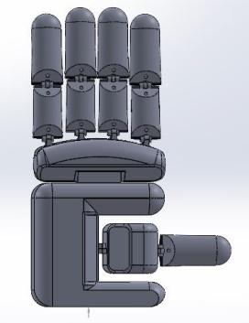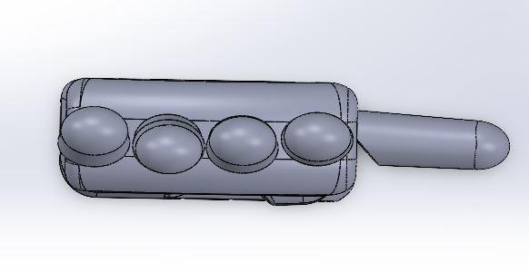
- Side, Front, and top views of Full-hand assembly

4. Motion Study
Motion study was done on the entire assembly to showcase the flexibility and agility of the entire hand, Shown below are four stages of the motion study from completely open to completely closed hand as seen in Fig.11

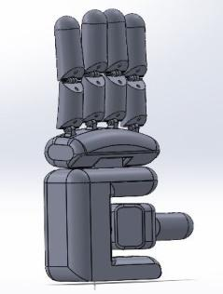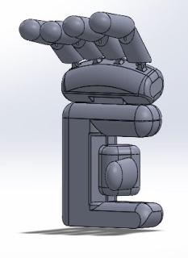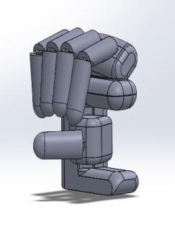
- 3 stages of motion study
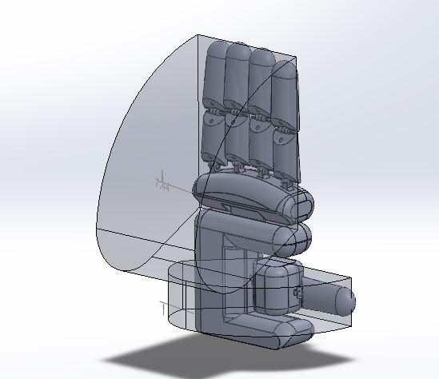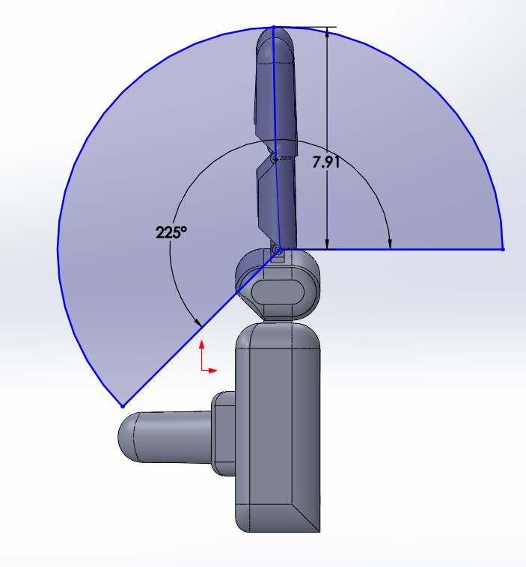
- Work Volume of the Robotic Hand
From the moment of the fingers and the palms, the work volume of this robotic hand can be understood from which the gripping range can be estimated which can be seen in Fig.12.

5. Material Selection
After having a complete model of the robotic hand, the materials were to be chosen by which the robotic hand would be made. Gurudu Rishank Reddy’s et.al Thesis from Blekinge Institute of Technology, helped in shortlisting what materials to be used for the hand. This is where The “Ashby chart” was used- shown in Fig.13 .This is essentially a chart that shows the scatter plot of material properties. So materials with good strength-to-weight ratio, density, tensile, stress, yield stress, Young’s modulus, and other parameters were shortlisted with the help of this chart (Highlighted in red)
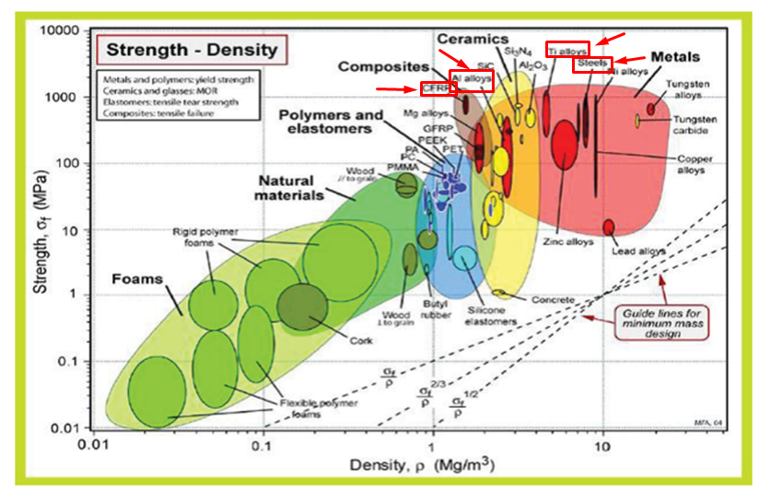
- Ashby Chart (Michael Ashby,1999)[9]
CFRP, AL6061, SS, and titanium were found to be suitable keeping in mind the above parameters.

6. Analysis
After shortlisting the materials, static structural analysis was done on each part of the model in Ansys workbench 2023. Through this static structural analysis, two main parameters were noted down from the analysis of every material and part. -Maximum deformation, The factor of safety FOS.
The analysis was done, selecting all the shortlisted materials and with all the individual parts. Regarding the boundary condition of the Load to be applied on the model Joel A. Cort's, et al 14 December 2010 [3] paper gave a detailed reasoning for the magnitude of load that the human hand could withstand. , And the value turned out to be 268N collectively for all fingers. So having acquired this information, the maximum load condition was set to be 268N, for all the materials and all the parts to obtain the best material in the dire circumstances. In the analysis of the palm of the hand, the maximum load considerations were taken, which is 268N. The forces applied are taken in such a way that they reenact the forces acting on a palm when a hand lifts an object. Static structural analysis was done on the two major parts of the hand, i.e. the upper and lower palms. In the static structural analysis, the forces were given on the mounting points of the palms. The load was applied in the direction of the Y-axis. The hinge modeled at the bottom was kept as a fixed support. From this FEA analysis, the maximum deformation resulted in 5.385x10⁻⁷m.

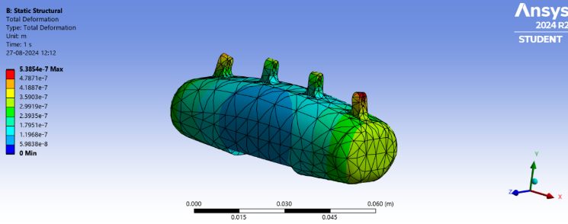
- Analysis on upper Palm keeping Structural steel as the base material
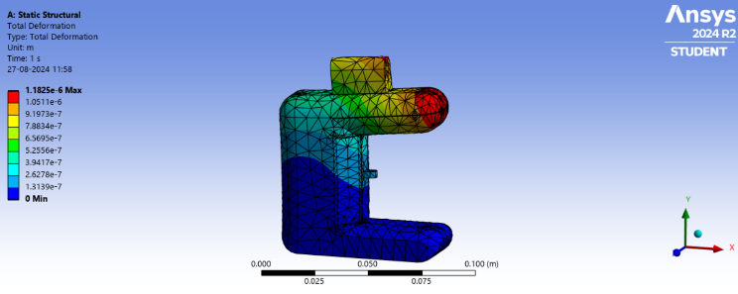
- Analysis on Lower Palm keeping Structural steel as the base material

Now regarding the FOS (Factor of safety), it is mathematically defined as
FOS= yield stress/ Allowable stress
The yield stress of structural steel is approximately 250 Mpa,
As mentioned earlier the maximum load a human finger can take is 268N. The load condition considered for this analysis is 5 times that value
268x5=1340N (Allowable load)
As Allowable stress = Load/area ; Load=1340N
Area = Lateral surface area of the mounting point cylinder, having a radius of 1.2mm and length of 3mm which results in an area of 22.61 mm²
Allowable stress = 1340N/22.61 mm²= 59.26 N/mm²; FOS = 250/(59.26x4)= 1.05

The second material to undergo static structural analysis is an aluminum alloy called AL6061-T6. Similar force directions and magnitudes were taken for this analysis as well, i.e. all forces acting in the Y axis and away from the palm and one force on each mounting point. From this analysis, the maximum deformation resulted to be 2.42x10⁻⁶m as shown below
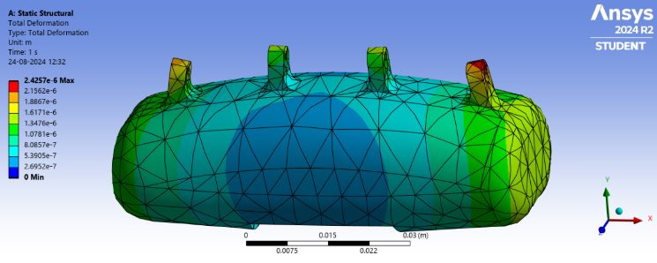
- Analysis on upper Palm keeping Al6061 T6 as the base material
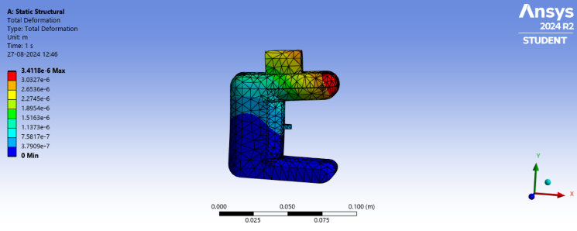
- Analysis on Lower Palm keeping Al6061 T6 as the base material
The yield stress of Al6061 alloy is 240 Mpa
Assuming the same force considerations as the previous analysis
Allowable load= 1340N over an area of 22.61 mm²
Allowable stress= Load/Area =1340N/ 22.61 mm²= 59.26N/mm² ; FOS= 240/(59.26x4)=1.01248
Here the denominator is multiplied by 4 as the load is distributed over 4 mounting points.

The third material to undergo this static structural analysis is CFRP (Carbon fiber refined plastic)
Unlike the other materials, this material is not a metal but rather a composite material. That being said, it has an excellent strength-to-weight ratio and toughness.
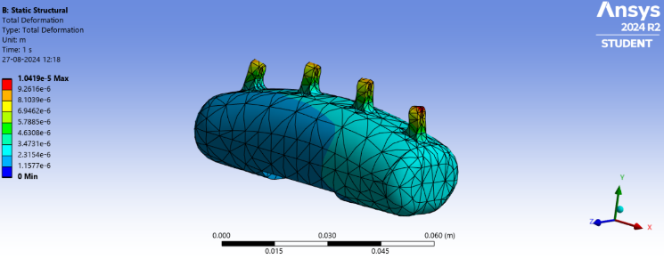
- Analysis on upper Palm keeping CFRP as the base material

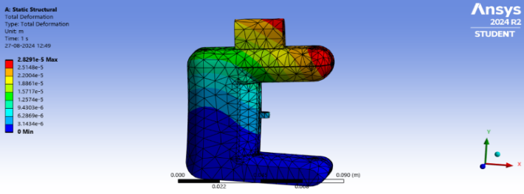
- Analysis on Lower Palm keeping CFRP as the base material
From this analysis, the maximum deformation resulted to be 2.85x10⁻⁵m
For the FOS calculation, the yield stress of CFRP is approximately 700 Mpa
Assuming the same force considerations as before, i.e. a load of 1340N over an area of 22.61mm².
The Allowable stress = 1340N/22.61mm²=59.26N/mm²; FOS=700/(59.26x4) = 2.95
Finally, the last material to undergo this analysis is Titanium. Titanium is known for its biocompatibility.
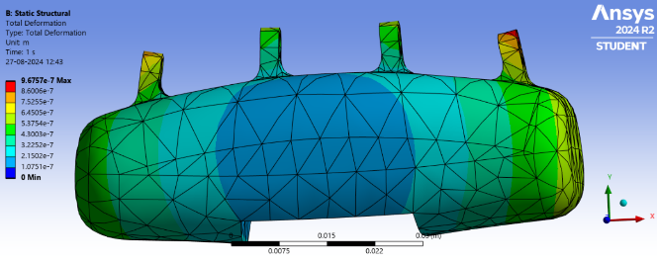
- Analysis on upper Palm keeping Titanium as the base material
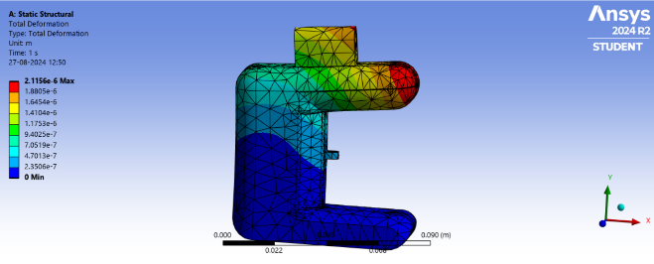
- Analysis on Lower Palm keeping CFRP as the base material
The maximum deformation observed in this material turned out to be 9.67x10⁻⁷m.
The yield stress for titanium is 241 Mpa and assuming the same force considerations as earlier i.e 1340N over an area of 22.61 mm²; Allowable stress= 1340N/22.61mm²=59.26N/mm²; FOS= 241/(59.26x4)=1.01
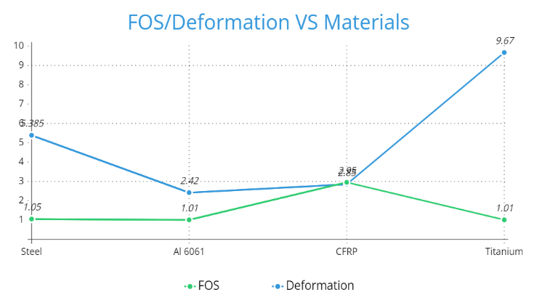
Fig. 22 Results

Table. 1 Results of static structural analysis
Material | Steel | Al 6061 | CFRP | Titanium
Deformation | 5.385x10⁻⁷m | 2.42x10⁻⁶m | 2.85x10⁻⁵m | 9.67x10⁻⁷m
FOS | 1.05 | 1.01 | 2.95 | 1.01

From the obtained graph it is evident that the material- CFRP is the best among the chosen materials, as it isn’t as weak as structural steel but at the same time economical, unlike titanium alloys which are very expensive.

7. Conclusion

This paper has presented a model and a payload analysis of an anthropomorphic robotic arm that resembles the human hand in terms of its structure and functionality. The arm’s ability to manipulate external loads throughout object manipulation activities has been investigated through careful modeling and finite element analysis (FEA); Carbon fiber refined plastic (CFRP) proved to be the best choice during construction. These findings demonstrate how robust this arm is for real-life applications such as human-robot collaboration and industrial automation.
8. Acknowledgment

We are deeply thankful to everyone who contributed to turning an idea into a tangible application. we extend our sincere gratitude to Dr. T.Ramamohan Rao, HOD-MED, Dr. S.V. Ramana, Principal of VCE, and the management of VCE, Hyderabad, for their support during our dissertation work.

9. References
- Zahnupriya Kalita , Sabyasachi Kashyap, Raktim Borah, Mukul Chandra Swargiary and Khandib Pao. ”model and Analysis of a Five Fingered Robotic Hand” Journal of Robotics and Automation, Vol. 15, Issue 2, (April 27th, 2023). pp. 45-62.
- Ahmad Ghanbari, Ramin Solaimani, Arash Rahmani, Farshid Tabatabaie “model and Simulating Five-Finger Robot Hand to Grasp Spherical Objects”. International Journal of Robotics Research, Vol. 28, Issue 4, 2013 pp. 301-318.
- Joel A. Cort, Jim R. Potvin. “Maximum isometric finger pull forces” Journal of Robotics Engineering, Vol. 5, Issue 2, . December 14, 2010, pp. 88-102.
- Li Tian, Nadia Magnenat Thalmann and jianmin Zheng Daniel Thalmann. “model of a Highly Biomimetic and Fully-Actuated Robotic Finger”. Journal of Biomechanics and Robotics, Vol. 12, Issue 3, September 18, 2021, pp. 175-190.
- Maxime Chalon, Markus Grebenstein, Thomas Wimbock, Gerd Hirzinger. “The thumb: Guidelines for a robotic model” Journal of Robotics and Automation Studies, Vol. 9, Issue 4, November 2010 pp. 201-216.
- Ever Grisol de Melo, Jéssica Christina dos Santos Silva, Tiago Borsoi Klein, Julian Polte, Eckart Uhlmann, and Jefferson de Oliveira Gomes “Evaluation of carbon fiber reinforced polymer – CFRP – machining by applying industrial robots” Science and Engineering of Composite Materials, Vol. 35, Issue 1, January 21, 2021, pp. 55-68.
- Agusril Syamsir, Norazman Mohamad Nor “Comparative study on aluminum alloy and carbon fiber reinforced polymer (CFRP) for military bridges” Structural Engineering Review, Vol. 18, Issue 3, August 2010, pp. 82-96.
- Gurudu Rishank Reddy Venkata Krishna Prashanth Eranki, “model and Structural Analysis of a Robotic Arm”, Department of Mechanical Engineering Blekinge Institute of Technology Karlskrona, Sweden 2016.
- Ashby, M. F. (1999). Materials selection in mechanical design (2nd ed.). Oxford, OX: Butterworth-Heinemann. p. 407. ISBN 0-7506-4357-9. OCLC 49708474

